**Project Description**

I will make a Chinese card game called Guan Dan. It is a 4-player card game and the rules are complicated. More information on this game can be found on this website: <https://www.pagat.com/climbing/guan_dan.html>.

The project will include an AI mode (offline mode) and hopefully a 4- player online mode.

**Competitive Analysis**

There are a few online Guan Dan programs that allow multiplayer connection, but I have not found one with AI mode, because of the extremely complicated techniques of playing. In my project, I will try to do develop a game AI that at least does not make the player feel boring.

**Structural Plan**

The project will include the file “CardGame.py”, which includes basic classes like Card, Deck, Player, Game, etc. Then there is a file “offlineMode.py”, which uses Pygame to run the offline mode of the game. Algorithms for the AI will be written in the “GameAI.py” file. Also, if the online mode is developed, there will also be “client.py” and “server.py” files.

**Algorithmic Plan**

The game AI is apparently the most complex part of the project. My current plan is to first organize the cards into different playable hands, and then calculate the weighted value of each hand (how much we want to get rid of a hand). The next step is to find the best hand to play based on a lot of factors, including the teammate’s possible cards left, the opponents’ possible cards left, as well as the cards that have already been played.

**Timeline Plan**

Apr 16: finish the basic process of the game without AI

Apr 20: finish a functional AI and decorate the UI a bit

Apr 23: improve the AI and make the offline mode playable

Apr 29: continue to improve the AI and add online mode if plausible

**Version Control Plan**

The code will be backed up in Google Drive.

The versions are named after the date of their last update.

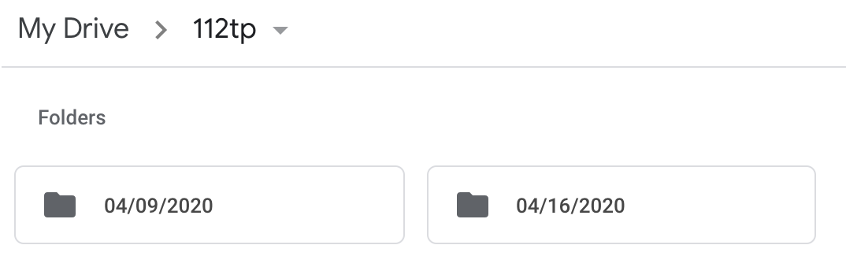

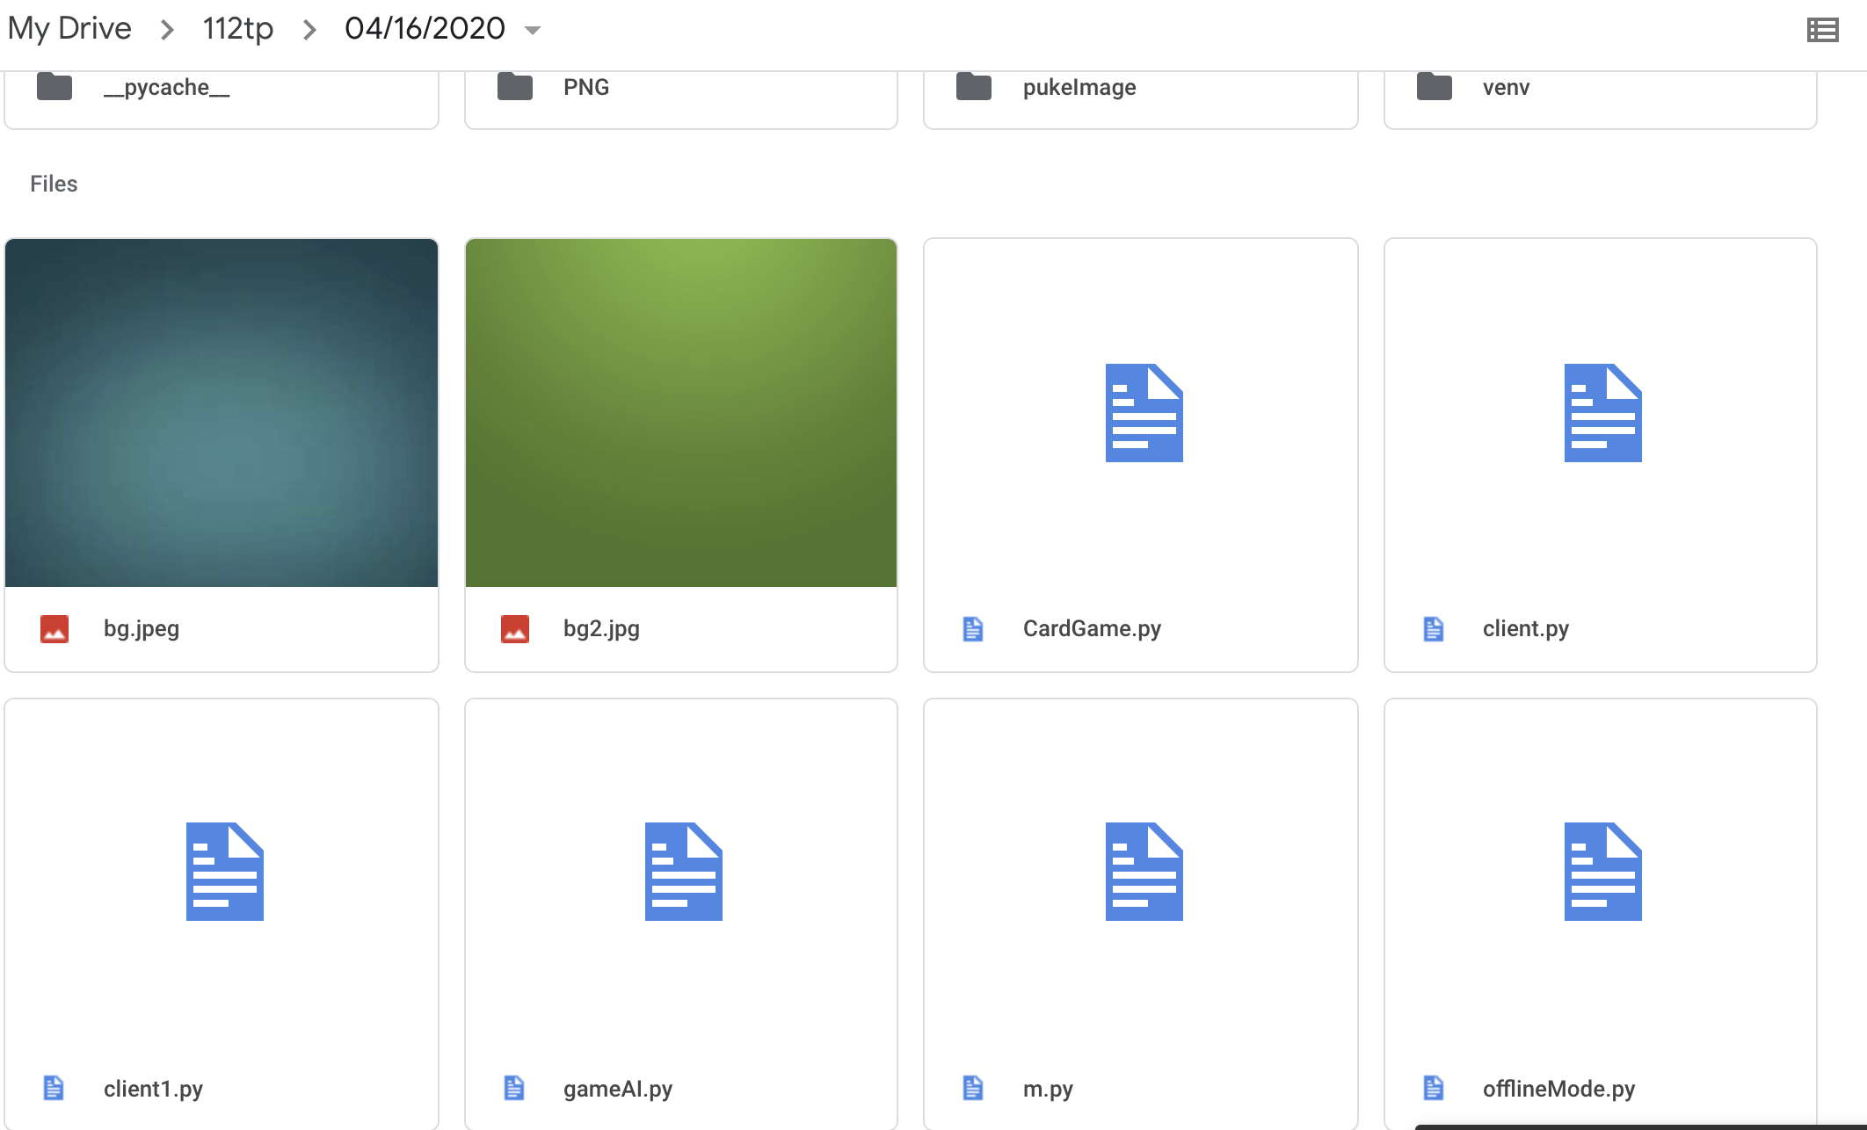

**Module List**

* Pygame
* Socket (after MVP)